Literature Survey:

Prepare below table after reading and analysing IEEE Papers:

|  |  |  |  |  |  |
| --- | --- | --- | --- | --- | --- |
| Sr. No | Title of Paper | Name of Authors |  | Published Year | Remarks |
| 1. | Stress Detection with Machine Learning and Deep Learning using Multimodal Physiological Data | Pramod Bobade  Vani M. |  | 2020 | Data of sensor modalities like three axis acceleration (ACC), electrocardiogram (ECG), blood volume pulse (BVP), body temperature (TEMP), respiration (RESP), electromyogram (EMG) and electrodermal activity (EDA) are for three physiological conditions - amusement, neutral and stress states, are taken from WESAD dataset. The accuracies for three-class (amusement vs. baseline vs. stress) and binary (stress vs. non-stress) classifications. machine learning techniques like K-Nearest Neighbour, Linear Discriminant Analysis, Random Forest, Decision Tree, AdaBoost and Kernel Support Vector Machine |
| 2. | A Decision Tree Optimised SVM Model for Stress Detection using Biosignals | Alana Paul Cruz, Aravind Pradeep, Kavali Riya Sivasankar |  | 2020 | ECG, EDR (ECG Derived Respiration),  Optimised Support Vector Machines (SVM) using decision trees. |
| 3. | Automatic Stress Detection Using Wearable Sensors and Machine Learning: A Review | Shruti Gedam  Sanchita Paul |  | 2020 | heart rate, heart rate variability and skin conductance.  Support vector machine, Random forest and K-Nearest Neighbor. |
| 4. | Machine Learning and IoT for Prediction and Detection of Stress | Mr.Purnendu Shekhar Pandey |  | 2020 | Heart beat , SVM Confusion Matrix, Logistic Regression , Classification algo(Navie Bayes, VF-15) , |
| 5. | Stress detection using deep neural networks | Russell Li1 and Zhandong Liu |  | 2020 | a deep 1D convolutional neural network and a deep multilayer perceptron neural network. signals measured from chest-worn and wrist-worn sensors to perform the two tasks of binary stress detection and 3-class emotion classification. |
| 6. | Mental Stress Detection in University Students using Machine Learning Algorithms | Ravinder Ahujaa , Alisha Bangab |  | 2019 | lassification algorithms Linear Regression, Naïve Bayes, Random Forest, and SVM is applied and sensitivity, specificity, and accuracy are used as a performance parameter. The accuracy and performance of data are further enhanced by applying 10-Fold Cross-Validation. The highest accuracy recorded was by Support Vector Machine (85.71%).  Perceived Stress Scale (PSS) |

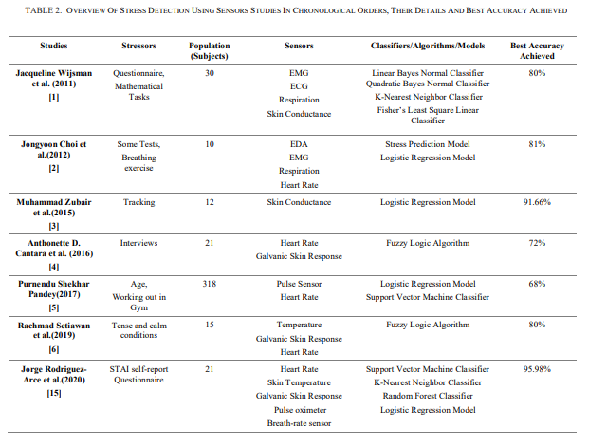

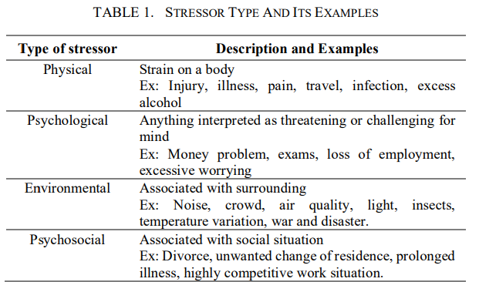

(Remarks: It will include all the points that you understand from the paper..such as methodology, algorthms, advantages, disadvantages, applications, etc.)

Stress Detection Project using Machine Learning

Project Description:

Stress, tension, and misery are undermining the psychological well-being of individuals. Each individual has a justification behind having an unpleasant life. Individuals frequently discuss their thoughts via web-based entertainment stages like on Instagram as posts and stories, and on Reddit through requesting ideas about their life on subreddits. In the beyond couple of years, many substance makers have approached to make content to assist individuals with their psychological wellness. Numerous associations can utilize pressure discovery to find which virtual entertainment clients are focused on to rapidly help them.

Stress discovery is a difficult undertaking, as there are so many words that can be utilized by individuals on their posts that can show regardless of whether an individual is having mental pressure.

The dataset I’m utilizing for this errand contains information presented on subreddits related on emotional wellness. This dataset contains different emotional well-being issues shared by individuals about their life.

People often share their feelings on social media platforms. Many organizations can use stress detection to find which social media users are stressed to help them quickly.

Programming Language Fundamentals:

Python : Basic Fundamentals (Videos are available on dashboard)

* Basic Fundamentals
* Literals
* Data Types
* Operators
* Loops
* Functions
* Import
* Strings
* OOP
* Date and Time
* RegEx



Access all the videos and try to make basic understanding of Python Code and fundamentals.

Modules:

numpy

pandas

nltk

re

string

matplotlib

sklearn

CountVectorizer

train_test_split

BernoulliNB

Contents related to these modules will be provided on dashboard in pdf / video formats as necessary.

Week 2: Tasks:

* Complete Literature Survey Table
* Watch / Read all the material provided for basic understanding